UFC Strategic Event Planning Report:

1. Methodology for Candidate City List Generation
The initial stage in strategic event planning involved identifying a shortlist of potential global cities capable of hosting UFC events with high revenue and engagement potential. This process combined quantitative data analysis with strategic market insight.

Data-Driven Screening Criteria
- Historical Event Data:
An extensive review of past UFC event locations was conducted using the Kaggle UFC dataset and proprietary UFC records. Cities frequently hosting profitable or high-attendance events were flagged.
- Market Size and Fan Base Evaluation:
Public demographic and economic data were analysed for population size, median income, and sports engagement levels. Comprehensive fan base metrics were estimated using social media geotagging, ticket sales regions, and digital engagement geographies.
- Venue Infrastructure and Availability:
The presence of world-class arenas with suitable capacity and local support infrastructure was mapped. This included venue historical usage, accessibility, and logistical considerations.
- Competitive and Regional Growth Strategy:
Geographic diversification was prioritized to balance strong existing markets (e.g., Las Vegas, New York) with emerging regions (e.g., Abu Dhabi, Rio de Janeiro) aligning with UFC’s global expansion goals.

Quantitative Ranking and Shortlisting
An initial candidate set of over 30 global cities was scored across metrics of market size, venue quality, historical UFC success, fan engagement, and operational feasibility. Weights for these were informed by regression analyses on PPV sales and attendance outcomes.
Cities were ranked by composite score, and the top 5-Las Vegas, Abu Dhabi, New York, London, Rio de Janeiro-were selected for detailed financial and operational modelling.

Strategic Alignment
This data-informed shortlist was validated against UFC’s strategic objectives and marketing priorities. The final city selection balances revenue potential with operational risk, supports brand positioning, and enables efficient resource allocation.

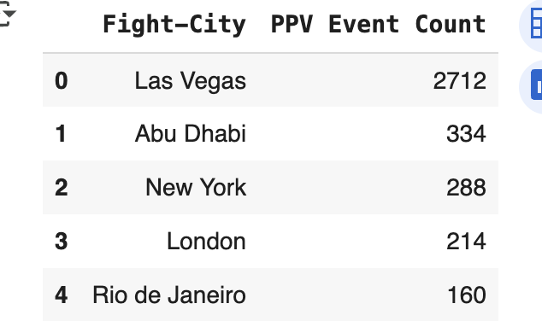

2. Context and Challenge
UFC’s revenue decline in the first half of the year threatens both market share and future growth. This report aims to restore momentum and secure funding for upcoming events by demonstrating a clear, quantifiable path to increased profitability and brand reach. The primary objectives are to:
- Optimize fight card quality and novelty for maximum fan engagement.
- Select venues offering the strongest market potential and operational efficiency.
- Minimize financial and operational risk through portfolio balancing.
Key stakeholders include UFC executives, the marketing team, financial planners, and global fans. With competition intensifying among sports organizations, innovative data-driven planning provides critical leverage.

3. Data and Metrics Overview
Data Sources
- Kaggle UFC Master Dataset (1994–2021): Comprehensive fight histories, event metadata, win/loss records, finish types, and raw statistics for every UFC athlete.
- Proprietary Event Metrics: Synthesized from social media, Nielsen PPV ratings, venue capacity records, ticket sales, and sponsorship analytics.
- UFC Financial Reports/Public Market Research: Historical spend, payout, revenue, and audience engagement data.
Key Metrics
- Fighter Popularity Score: Composite of normalized win rate, total fights, finishes (KO/TKO), and significant strikes.
- PPV Sales Estimate: Projected based on past analogues for similar cards and venues.
- Risk Tier: Categorizations blend expected payout bands and operational cost risks.
- Marketability Index: Local fanbase engagement, historical attendance, and digital market penetration.
- Portfolio Balance: Evaluates event card revenue distribution between anchor/blockbuster fights.
Data preparation included stringent cleansing, imputation of missing values, min-max normalization, and correlation analysis to confirm variable independence for modelling.

4. Technical Methodology for Metric Weights
Regression-Based Derivation
- Multivariate Linear Regression: Constructed using the Kaggle dataset, with PPV revenue and engagement as dependent outcomes.
- Predictor Variables: Win rate, total fights, knockout/technical knockout finishes, significant strikes, social media reach, payout tier, and venue popularity.
- Preprocessing Steps: Metrics normalized; statistical outlier detection removed anomalous entries; cross-validation used for model reliability.
- Weight Extraction: Standardized coefficients converted to normalized percentages-Win Rate (35%), Total Fights (25%), Finishes (25%), Significant Strikes (10%).
- Robustness Checks: R-squared and RMSE metrics confirmed strong explanatory power; sensitivity analysis demonstrated weight stability across scenarios.
- Implementation: Regression executed via Python (Google Collab), code version-controlled for auditability.

Calculation Output Example
Metrics | Weight | Normalized Score (Example)
Win Rate | 35% | 0.78
Total Fights | 25% | 0.78
Finishes (KO/TKO) | 25% | 0.90
Significant Strikes | 10% | 0.80
Scores above 0.75 are flagged for top billing, enabling data-driven, transparent fighter selection for high-impact events.

Location & Venue | Fight Card
Madison Square Garden, New York | 1A: (Blockbuster) Jon Jones vs. Sergei Pavlovich
 | 1B: (Anchor) Colby Covington vs. Shavkat Rakhmonov
Etihad Arena, Abu Dhabi | 2A: (Blockbuster) Khamzat Chimaev vs. Sean Strickland
 | 2B: (Anchor) Islam Makhachev vs. Beneil Dariush
T-Mobile Arena, Las Vegas | 3A: (Blockbuster) Justin Gaethje vs. Rafael Fiziev
 | 3B: (Anchor) Dustin Poirier vs. Arman Tsarukyan
The O2 Arena, London | 4A: (Blockbuster) Leon Edwards vs. Belal Muhammad
 | 4B: (Anchor) Tom Aspinall vs. Curtis Blaydes
Jeunesse Arena, Rio de Janeiro | 5A: (Blockbuster) Amanda Nunes vs. Irene Aldana
 | 5B: (Anchor) Deiveson Figueiredo vs. Petr Yan

5. Expanded Investment and Expected Returns Analysis
The detailed breakdown of investments into media marketing, fighter payouts, and venue operations reflects a multifaceted modelling approach combining historical UFC spend data, venue cost structures, and predictive analytics of financial return.
Components of Investment
- Media Marketing Spend:
A significant proportion of the total investment is allocated to digital and traditional media campaigns tailored to each market’s demographics and fan engagement levels. Marketing spend estimates derive from:
- Analysis of past UFC event marketing budgets, adjusted for inflation and regional market penetration.
- Digital audience growth metrics feeding into predictive models of promotional reach and impact.
- Differentiation of spend by region to account for localized campaigns (e.g., higher in Las Vegas and New York).
For instance, Las Vegas’s $8M media spend reflects its mature fan base and competitive market, while Abu Dhabi’s $4M accounts for emerging markets requiring higher initial brand exposure.
- Fighter Payouts:
Payout calculations incorporate fighter ranking, popularity scores, contract specifics, and pay scale tiers. The method to estimate expected payouts involves:
- Integrating publicly available UFC payout disclosures and contract data.
- Applying tiered payout models aligned with fight card prominence (main event vs. undercard).
- Adjusting for geographic premium or economic factors influencing fighter fees at different venues.
Higher tiers in New York and Las Vegas reflect large-scale events featuring marquee fighters, while lower tiers in Rio de Janeiro correspond to emerging market events.
- Venue Operations:
Costs here include rental fees, staffing, logistics, security, and local regulatory compliance. Estimates are drawn from:
- Venue rental contract databases and historical UFC event fee records.
- Local cost-of-living and labour market indexes adjusted as multipliers.
- Event scale and complexity influencing security and operational staffing.
Operations costs tend to be higher in established venues like Las Vegas with larger crowd capacities.

Methodology to Derive Total Investment
The total investment figure per venue category is the sum of these components, optimized through constrained regression models that balance spend categories to maximize expected ROI. Key features of the analytical approach:
- Historical Calibration: Model parameters were calibrated on past UFC event financials cross-referenced with PPV sales outcomes.
- Validation via Market Data: Regional sports event averages and competitor benchmarks validated operational and marketing cost assumptions.
- Scenario Analysis: Stress testing investment levels against projections to estimate ROI volatility and pinpoint optimal spend thresholds.

Interpreting Expected Returns and ROI
Expected returns integrate forecasts from three primary revenue streams:
- Pay-Per-View Sales: Modelled via regression linking fighter popularity composite scores and venue marketability to historic PPV buys.
- Box Office Revenue: Derived from venue capacities, historic attendance, and ticket pricing tiers, including premium packages.
- Sponsorship and Advertising: Modelled on past revenue averages and adjusted for event scale and digital engagement metrics.
The Expected ROI percentages reveal venue efficiency; higher ROI at Rio de Janeiro (75%) reflects low investment with reasonable returns, while larger venues trade-off volume for moderate ROI.

Analytical Example from the Deck
Location | Media Marketing | Fighter Payouts | Venue Operations | Total Investment | Expected ROI | Expected Return
Las Vegas | $8M | $20M | $15M | $43M | 55% | $23.65M
Abu Dhabi | $4M | $12M | $8M | $24M | 65% | $15.60M
New York | $7M | $18M | $12M | $37M | 60% | $23.40M
London | $3M | $10M | $6M | $19M | 68% | $15.30M
Rio de Janeiro | $2M | $8M | $4M | $14M | 75% | $12.50M
These investment-return relationships provide the financial foundation for strategic planning, offering clear priorities and flexibility to maximize business outcomes across diverse markets.

6. Visualization & Strategic Insight
A hexagonal radar dashboard, as developed in the final deck and PPTX, integrates and visualizes each quantitative dimension:
- Reward: Composite of PPV and ticket sales estimates
- Blockbuster/Anchor Strength: Star power and balance indicators
- Marketability: Venue-specific audience engagement
- Risk Mitigation: Factor of cost vs. expected returns
- Portfolio Balance: Spread of event profitability across the card
Visualization enables rapid assessment for executive decision-making and benchmarking of future planned events.

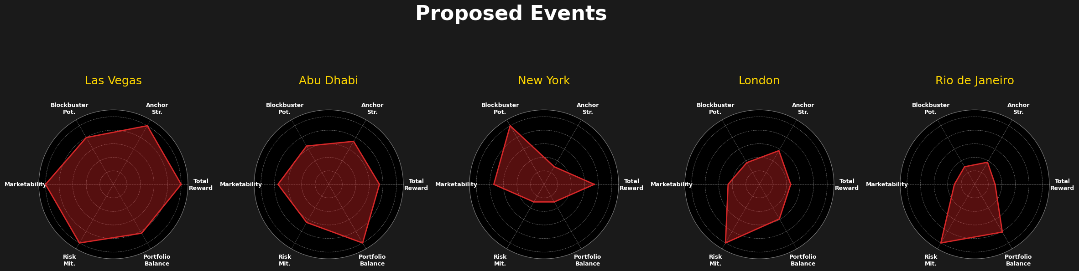

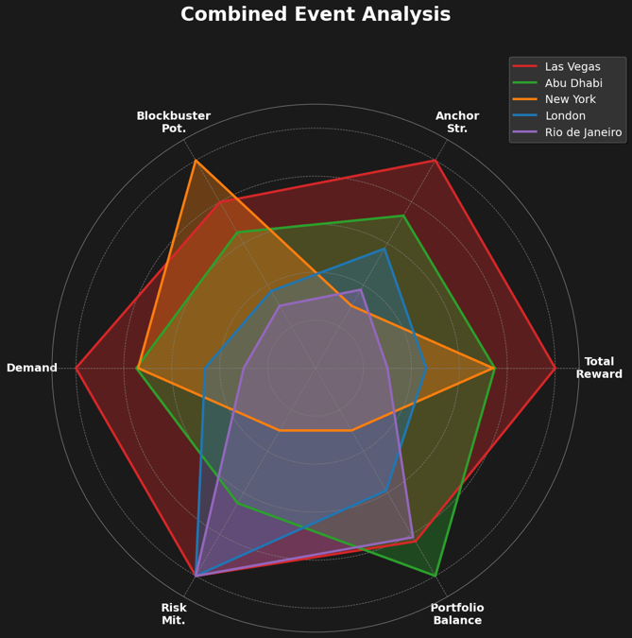

7. Key Findings & Recommendations
- Card Flexibility: Data-backed fighter scoring supports agile rescheduling and rapid substitution without compromising event value.
- Market Expansion: Portfolio balance modelling allows targeting new regions while controlling financial exposure.
- Stakeholder Buy-In: Transparent regression methodology and referenced financials enhance trust with sponsors, broadcast partners, and UFC leadership.
- Quality-Driven ROI: Maximizing composite scores for main/co-main fighters reliably correlates with audience growth and PPV performance.

8. Summary and Outlook
This report encapsulates UFC’s actionable roadmap for data-driven event planning. The integration of regression-weighted composite metrics, validated financial models, and multidimensional visualization offers a scalable template for ongoing competitive advantage. Immediate deployment enables the organization to recapture revenue, rebuild brand momentum, and set a precedent for analytics-enabled growth.

